
2019 Year 11 Physics

Task 10: Test 5 – Motion

Waves Test (Sound)
Name: ____________________________
_______ /45 marks

- 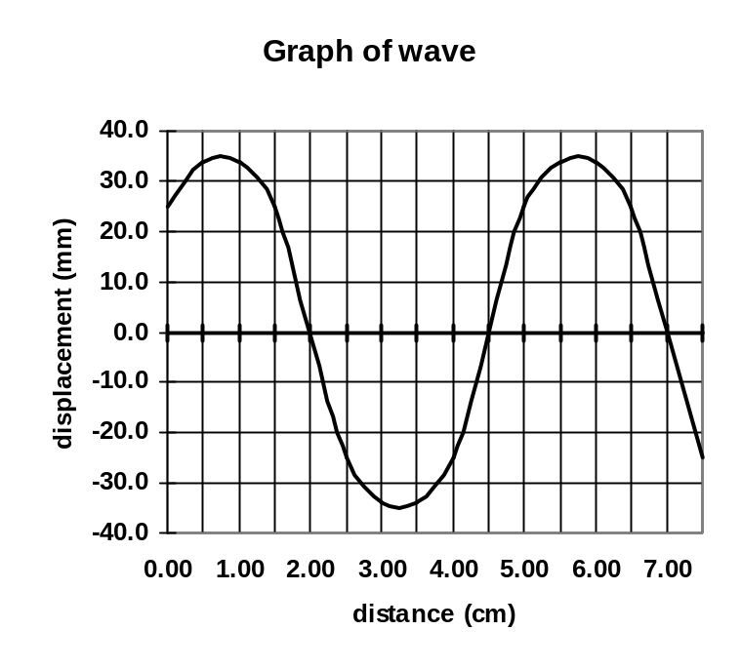Three students are using a piece of string to make a standing wave. The following graph shows the wavelength of part of the string at one particular instance. What is the amplitude and wavelength of the wave the string creates. (2 marks)

Amplitude ______________

Wavelength ______________

- If the wave in the graph for question (1) is travelling at 4.00 ms⁻¹, what is the period of the wave? (3 marks)

- Complete the following: (3 marks)
- In a region of stationary waves, nodes indicate __________________ vibration of particles.
- The number of waves in a given time. ____________________
- The distance between two crests on a displacement / time graph is called the __________.

- Waves can travel as longitudinal waves or transverse waves. Fully explain the difference giving one example of each. (3 marks)
___________________________________________________________________________
____________________________________________________________________________________________________________________________________________________________________________________________________________________________________________________________________________________________________________________________________________________________________________________________

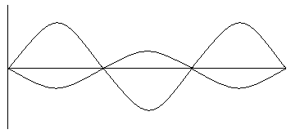
- A student has set up two waves on a dual beam CRO. She then adds them together.
Draw the resultant wave. (2 marks)

- Bending of waves due to passing around or through openings is called ___________________
(1 mark)

- Complete the following diagrams for reflection of waves at harbour wall and refraction of sound of bell above water. (3 marks)

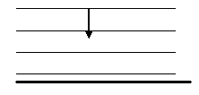
air
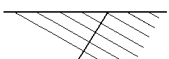

water

Harbour wall Bell

- Matt starts by running his finger around the top of a wine glass. He then increases the speed until it sounds a note. Explain why the glass sounds the note and what is the name given to this phenomena. (3 marks)

______________________________________________________________________________________________________________________________________________________________________________________________________________________________________________________________________________________________________________________________________________________________________________________________________________________________________________________________________________________________________________________________________________________________________________________________________________________
- Andrew is blowing air over the end of a pipe. When he blows softly across the end, a microphone connected to a C.R.O. shows a frequency of 256 Hz. When he blows over the pipe much harder, a frequency of 1024 Hz is shown on the screen. The speed of sound on the day is 332 ms⁻¹.
  - Is the pipe open at both ends or open at one end and closed at the other? (1 marks)
______________________________________________________________________

  - Fully explain the answer you gave. (3 marks) _________________________________________________________________________________________________________________________________________________________________________________________________________________________________________________________________________________________________________________________________________________________________________________________________________________________________________________________________________________________________________________
  - What is the length of the pipe assuming the 256 Hz is the fundamental frequency?
(2 marks)

- A closed pipe is 40.0 cm long and is made to vibrate in its fundamental frequency. What is the period of the wave? (3 marks)

11. Imagine a situation in which a sound wave, with a wavelength of 1.6 m is reflected straight back from a flat wall, forming a standing wave pattern. You are walking towards the wall. As you approach the wall:

a) What is the shortest distance you need to move to go from one "quiet spot" to the next?
__________________________________________________________________________________________________________________________________________________________________________________________________________________________________________
(2)
b) What is the position of these "quiet spots" called?__________________________
(1)
c) What is the position of the "loud spots" called?____________________________
(1)
d) What is the separation distance between a "quiet spot" and a "loud spot"? (2)
__________________________________________________________________________________________________________________________________________________________________________________________________________________________________________

12. A dolphin’s social vocal range is 1 – 50 kHz, while it’s echolocation frequency can go as high as 150kHz, whereas most bat’s echolocation frequencies are approximately 100,000 Hz

a) If the speed of sound in the sea is 1500 m/s what is the smallest object that can reflect the dolphin’s sonar wave?

__________________________________________________________________________________________________________________________________________________________________________________________________________________________________________
(3)

b) Compare the dolphin’s minimum detected object compared to a bat’s minimum detected object while the bat is hunting prey?
________________________________________________________________________________________________________________________________________________________________________________________________________________________________________________________________________________________________________________________
(2)

13. An ambulance started its siren 200m after leaving the scene of an accident. After a short time the intensity of the sound was measured as being 15% of the original. Assuming the volume of the siren hadn’t changed how far away was the ambulance when the intensity was measured.
______________________________________________________________________________________________________________________________________________________________________________________________________________________________________________________________________________________________________________________________________________________________________________________________________
(3)

14. What are the advantages of using very high frequency ultrasounds compared to using lower frequencies ultrasounds in medical uses.

__________________________________________________________________________________________________________________________________________________________________________________________________________________________________________
____________________________________________________________________________________________________________________________________________________________
(3)

